## ****Podcast about Pets and COVID-19 from Pets on Q****

## Can our animals catch the Corona Virus? How do you communicate the facts during this COVID19 Crisis?

[](http://petsonq.com/petnews)

[**Pet News**](http://petsonq.com/petnews) **from Pets on Q (**<https://petsonq.com/>)**.**

Pets on Q is the industry leader in animal marketing, from production to booking a social media influencer. PoQ is leading the charge in changing the industry for the betterment of animals. Using temperament approved and even shelter animals in as much as we can.

[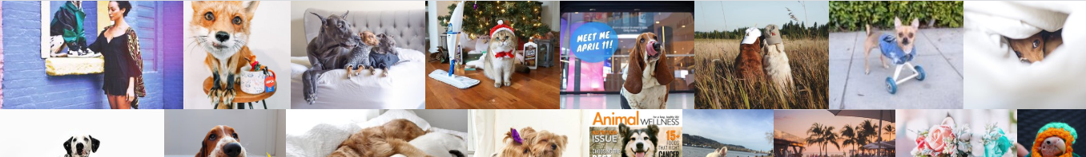](https://open.spotify.com/episode/79CVrpMWBlVxEo0QxGZ5K6?t=0)

[](https://open.spotify.com/episode/33knijey6ogK2IXAnym5dv)

In this episode of Pet News, we talk with Aimee Gilbreath of Found Animals to go over the facts of this disease. Can our pets catch or carry this disease? How do we keep our families safe? We also spoke to Leigh D'Angelo an expert in crisis communications, she's here to share some important tips that influencers and experts in the pet world should keep in mind at a time like this.

What are your thoughts? Let us know, also what else do you want us to cover next?

DM us @petsonQ or email us at [Colleen@petsonQ.com](mailto:Colleen@petsonQ.com)

[](https://open.spotify.com/episode/33knijey6ogK2IXAnym5dv)

[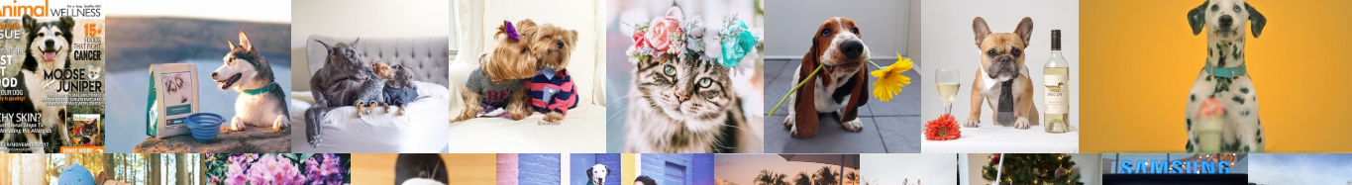](https://open.spotify.com/episode/79CVrpMWBlVxEo0QxGZ5K6?t=0)

[](https://www.instagram.com/petsonq/)[](https://www.youtube.com/channel/UCyBVBAcsah2kUlxwco1eKVA)[](https://www.facebook.com/PetsonQ/)[](https://twitter.com/petsonq)[](https://www.linkedin.com/company/pets-on-q)[](https://petsonq.com/aboutus)[](https://petsonq.com/work)[](http://petsonq.com/petnews)[](https://petsonq.com/contact-1)